**Home Task 5**

**Fundamentals of Programming**

Instructor: Sir Affan

Name: Syed Muhammad Ali Akbar

CMS: 477723

**Code 1:**

//Task 1

#include <iostream>

using namespace std;

int main()

{

    int lcm=0;

    int hcf;

    int num1;

    cout<<"Enter first number: "<<endl;

    cin>>num1;

    int num2;

    cout<<"Enter second number: "<<endl;

    cin>>num2;

    int i;

    if (num1>num2)

    {

        for (i=num2;i>0;i--)

        {

            if(num1%i==0&&num2%i==0)

            {

                hcf=i;

                break;

            }

            continue;

        }

        cout<<"The highest common factor is  "<<hcf<<endl;

    }

    else

    {

        for (i=num1;i>0;i--)

        {

            if(num1%i==0&&num2%i==0)

            {

                hcf=i;

                break;

            }

            continue;

        }

        cout<<"The highest common factor is  "<<hcf<<endl;

    }

    lcm=((num1*num2)/hcf);

    cout<< "The LCM between "<<num1<<" and "<<num2<<" is " <<lcm<<endl;

    return 0;

}

**Output 1:**

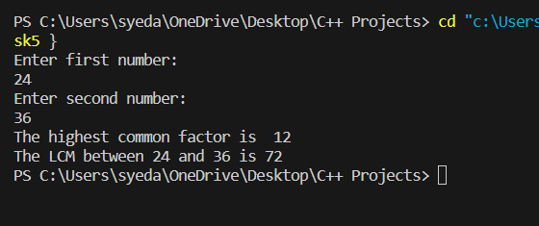

**Code 2:**

//Task 2

# include <iostream>

using namespace std;

int main()

{

    int t_start;

    cout<<"Enter first term of arithmetic progression: "<<endl;

    cin>>t_start;

    int diff;

    cout<<"Enter difference between subsequent terms of arithmetic progression: "<<endl;

    cin>>diff;

    int l;

    cout<< " Till what term do you want the sum of the progression? "<<endl;

    cin>>l;

    int sum=0;

    int term=t_start;

    int index=l;

    while(index>=1)

    {

        sum+=term;

        term+=diff;

        index--;

    }

    cout<<"The sum of the arithmetic progression till the " <<l<< " th term is " <<sum<<endl;

    return 0;

}

**Output 2:**

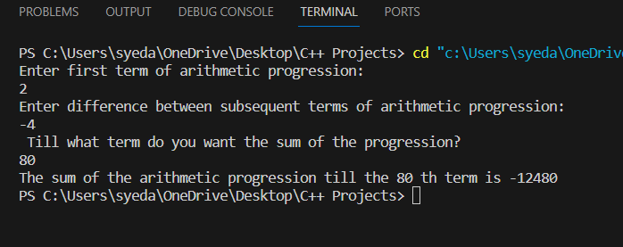

**Code 3 :**

//Task 3

#include <iostream>

using namespace std;

int main()

{

    for (int i = 1; i <= 5; i++)

    {

        for (int sp = 1; sp <= 5 - i; sp++)

        {

            cout << " ";

        }

        for (int star = 1; star <= 2 * i - 1; star++)

        {

            cout << "*";

        }

        cout << endl;

    }

    for (int i = 4; i >= 1; i--)

    {

        for (int sp = 1; sp <= 5 - i; sp++)

        {

            cout << " ";

        }

        for (int star = 1; star <= 2 * i - 1; star++)

        {

            cout << "*";

        }

        cout << endl;

    }

    return 0;

}

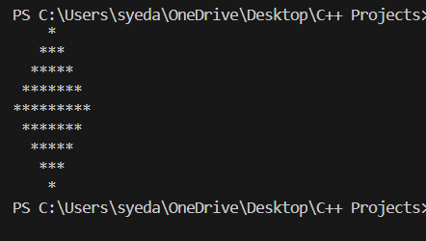**Output 3 :**

**Code 4 :**

//Task 4

#include <iostream>

using namespace std;

int main()

{

    int quo;

    int dec_num;

    cout<<" Enter any decimal number: "<<endl;

    cin>>dec_num;

    cout<<"Binary Number (Read from bottom to top) is: "<<endl;

    while (quo>=1)

    {

        quo=dec_num/2;

        cout<<dec_num%2<<endl;

        dec_num=quo;

    }

    return 0;

}

**Output 4 :**

